Hey Gringo!
Assemblage and Essay
By
International Artist
Michael Bowen
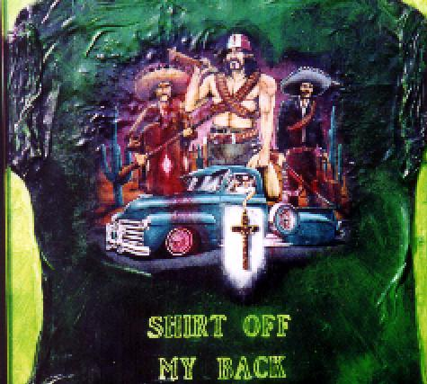
http://www.woodstocknation.org/cigarette.htmhttp://www.woodstocknation.org/cigarette.htm
"donde esta la pastura"
click on picture above and think
Name of work: "Hey Gringo"
Story by Michael Bowen written in Florence Italy 1998
The cross in the center of the assemblage belonged to beat artist John Reed. John was my friend starting at 16 when we began painting together. He was in San Francisco during the "Beat" period then returned to L.A. after being busted as the ghost of the Fox theater in 1963. Then, in L.A., he lived with my friend, the art famed Kienholz, (who had a 9 page obituary in last year's Atlantic Monthly describing his burial: buried in his car with bottle of wine and playing cards splayed in hand, a living, ooops dead, assemblage himself), John Altoon and Wallace Berman, and was part of Ferus gallery in L.A. John Reed became patronized by Walter Hopps, curator of the Corcoran in Washington, D.C., and was given housing just to paint and live in by Hopps in Pasadena. Bruce Nauman, artist now, $10 or so million a year, lived there with him, both broke. John had odd obsessions. He liked P 38 fighter planes, models, photos, anything, and he liked Jesus. He drank a little and sat around in churches alone. When Arthur Monroe and I were exhibited together with Pollack, Motherwell, Burroughs cut-ups and all in the Whitney's Beat Culture and the New America show, we both thought others should have been included. Monroe went to work and soon another parallel exhibit was planned in San Francisco when the Whitney, and our works (they added another of mine) hit town. The Somar show was born. Arthur was the curator and I became kind of a long-range gopher hunting down some of the lost and left out. I went to Vegas to see Roberto and looked through 10,000 negatives. It was 104 degrees at 8a.m. Then we left for Hell A. and home. John Reed was of course on my Hell A list. While there, a party was held for Isa and I at a film producer's in Pasadena. At the party, a man said he knew an artist and his name was John Reed. This man was a billionaire. When I questioned him a little, it turned out that he used to have a beer occasionally with John Reed about 10 years or more before. Then he kind of whispered, "You know, he hit the skids?" Anyway, it turned out that he was alive (barely) and was still in Pasadena. He had been living under a bush at the Pasadena public library for 12 years. Therefore, the producer we were staying with suggested we get a film crew together and hunt until we found John. The producer had just released a film he did call "Timothy Leary's Dead", which I am in. So, maybe he sensed something. We found John Reed. We filmed and interviewed him, gave him some money(useless), tried to get him medical, ditto, studio, ditto, paint, ditto ... John then told Isa and I that 12 years before he had left all his paintings rolled up next to his small black briefcase in the basement of the Hopps house, from which he had been driven because of drink/church combination. We retrieved the works and briefcase exactly as, and where, he said they would be found. We left and went home to San Francisco. John Reed was in Arthur's Somar show. Arthur and I, too, and also Jay de Feo, Michael McCracken and Roberto Ayala. (I can send you some of his photos of Kaufman or others; Roberto is at last becoming art famed) Robertos and John Reeds works are now in many current books of the Beat period. period. So, John Reed died a week after all this stuff took place in Pasadena. We opened the briefcase, I guess for the 1st time in 13 years. Inside we found the incredible art of Wallace Berman. In addition, the CROSS-in the attached assemblage.

