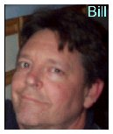
Lightning Rod Captures Bill Ectric
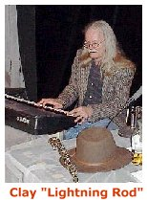
Clay "Lightning Rod" January is a writer, poet, musican, singer, and instigator. His syndicated column is called The Poet's Eye. Clay and his partner Doreen Peri have released a wonderfully atmospheric CD of music, spoken word, and song called Oral Sets. This interview first appeared on Clay and Doreen's eclectic website, Studio Eight Community.

Lightning Rod: I can see by your work and your autobiographical material that you have been bitten by the writing bug for some time. Tell me about your first intrigue with the addiction.
Bill: When I was about six years old my father brought home a Royal typewriter. It was jet black and of course, not electric, and he cleaned it up proudly and placed it on a stand beside his desk. My dad's job was to repair typewriters and adding machines and such. Somebody gave him this typewriter instead of cash. Because of computers, that job almost doesn't exist anymore. Nowadays they just replace a circuit board or something. Back then, typewriters had all these moving parts, springs and levers and so forth. My dad was a big letter writer to newspapers and stuff. Something happened in town that he didn't like, man, he'd be writing a letter to the newspaper, just typing away on that Royal, like, "I wish the Mayor could explain to me how he justifies spending tax payers' money to fund police bothering kids on bicycles just because they take up one parking space with three bicycles in front of the Rexall drug store where they spend their money on comic books and cokes and French fries" or some such thing. He was always writing letters.

Interviews
My Dad let me use the typewriter. I came up ideas for stories and ask my mother how to spell words and stuff. If I asked my dad, he'd say, "Look it up in the dictionary."
I made up my own comic books when I got a little older. I would staple together 10 pages of white typing paper and draw the square comic book panels and all, and for every super hero in the real comics, I made up my own super hero. Instead of "The Flash" I'd have a guy called "The Dash" and stuff like that.
I ran into trouble when it came to sex. I was self conscious about drawing women because my dad would say something like, "She has a big butt, doesn't she?" and I would be embarrassed. But when I wrote, with no drawings, it was easier. I saw the James Bond movie, Goldfinger, in 1964 when I was about 10 years old. That’s still my favorite Bond movie. I made up my own spy, named Buck Krasby, of all things.
As for why I liked to write, I don't know, it was just naturally what I liked. Some kids found they were good at baseball or math. It wasn't anything I can explain, I was just naturally drawn to it. I sensed early on that there was a whole world of writers and film makers and TV shows and that it was a legitimate pastime. People thought I was weird, that I lived in my own dream world, so I tried to legitimize it by saying, "It's a profession. The people who make TV shows and books are making a living, just like baseball players make a living." I felt I had to defend myself for wanting to make up stories and people.
When I got a little older I really got into horror movies. I especially liked those Hammer films with Christopher Lee and Peter Cushing, because you could have a suave, brawny vampire biting a nubile, lusty girl on the neck without having to openly acknowledge sexual urges. I first learned about Edgar Allen Poe through those Roger Corman "B" movies with Vincent Price and Boris Karloff. I struggled through reading Frankenstein by Mary Shelly and Dracula by Bram Stoker because I had seen the movies.
Then I discovered satire and comedy through Robert Benchley and James Thurber. Young people need something that makes them laugh, to take their mind off of their problems. I learned that there had been a circle of writers who always hung out together in the 1930's. They were called the "Algonquin Round Table" and included such writers as Dorothy Parker, Robert Sherwood, George S. Kaufman, Edna Ferber, Robert Benchley, and others. I thought, how cool would that be, to be a part of a group of writers who could respond to each other in print, sometimes sparring, sometimes praising, sometimes sharing in each other's work. How some kids might imagine playing for the Yankees, I saw myself as someday belonging to a group of writers.

In high school I was very impressed with Henry David Thoreau. At one point I asked my parents if they could buy me a cabin in the woods. They knew better. I'm not much of an outdoorsman and I’m fond of electricity. I would have probably frozen to death.
I got sidetracked for many reasons. Self-doubt, the need to earn a living in a "practical" career, so many things. To this day I don't know why I joined the Navy as soon as I graduated from high school, but in the Navy I met people who told me about Hunter S. Thompson, Jack Kerouac, Carlos Castaneda, Allen Ginsberg, The Firesign Theatre, and all kinds of . . . trippy . . . stuff.
LR: What is your ambition as a writer?
Bill: Ok, I would like to be recognized as a writer. I don't know why. The thing is, I've had many jobs; you have to feed yourself, you know, and I just think that, wouldn't it be great if I could get paid for writing, which is what I love to do? Like, if a person loves building stuff out of wood, wouldn't it be great if they could be paid to be a carpenter or a construction worker? Or if you love animals, wouldn't it be great to either work at a zoo or as a veterinarian or an animal trainer? One side of me wants to do good in the world. Like, if my writing could help others in some way, to fight poverty and depression and war, that would be my contribution to society, but on the other hand, I just like it and I don't know why. Of course I want people to like what I write. How can anyone say they don't care what anyone thinks? If someone designs a new car, of course they hope other people like it. If you're a chef and you cook up a dish, you hope others will say, "This tastes great!" It's not being self-centered. Or if it is, then it's natural. It's not wrong. You have people like Vincent van Gogh, who did not make much money for his paintings. His brother was his agent. Apparently Van Gogh just wanted enough money to keep painting and didn't care about anything else. I have a family I want to support, and I will support them. I love them and without them I might not be alive. That’s another story.
LR: Can a writer make a difference in the world? If so, how? Bill with writer Chris Hutson outside Fuel Coffee House in Jacksonville, FL Jamelah Earle of LitKicks, Clay 'Lightning Rod' January, Doreen Peri, and Billectric at the Bowery Poetry Club in New York . Bill with Caryn Suarez, publisher of POW Magazine (Promoting Outstanding Writers) Bill: Well, sure, a writer can make a difference in different ways. If a writer reveals personal feelings, maybe other people can say, "I'm not the only one who has felt this way. I'm not alone." One of the things that defines "Beat" writing is the irreverent search for truths, not just for shock value, but to speak out. Like, a lot of conservative Christians will say that homosexuality is a sin, and no one is born that way, they choose it. Then we see on television that there are actually some babies born with both sex organs, male and female. That child didn't choose that. How do they explain that? Or, we have people that include marijuana in with much more dangerous drugs and waste time and money, not to mention ruining people's lives, for what? For nothing, really. You can have a martini but you can't smoke a joint. Obviously, some writers make a bigger difference than others. Henry David Thoreau spoke out against slavery and war. He is still cited today as an influence on people like Dr. Martin Luther King, Jr. But it doesn't have to be major issues. It can be, does my writing give someone a laugh in the middle of a bad time, or whatever.

LR: Besides your roles as wit and sage, how do you see yourself as a writer?
Bill: Simply because of my age, I have had a lot of experiences that . . . I don't know. How do I see myself? There's a dichotomy. On one hand, I really like the bizarre literary experiments, like William S. Burroughs' "cut up" writing technique, James Joyce's Ulysses, Derrida's deconstruction; but on the other hand, I like the pop escapism of a Quentin Tarrentino film or Hannibal Lecter, or even Indiana Jones. You know, a lot of people are afraid to admit they like pop. Hell, it's all good. If Shakespeare had video he would have used it. I don't care. Right in the middle of something commercial there can also be something profound.
That's why, in my story Cut Up (The Stolen Scroll), I included an experiment in cutting up a paragraph and re-arranging it, but I based it around a normal story about young people with problems. And murder. And in my story Time Adjusters, I fool around with weird, stream of consciousness ramblings, but I base it on the premise that time and space are falling apart, and the surreal stuff is just a part of the story. I wouldn't expect anyone to read just the crazy ramblings without some structure to follow. It would be pretentious. Above & below: Bill on his way to from Spain to Tangier, Morocco by ferry, 1973
LR: How do you choose your subject matter?
Bill: I write what I would like to read. If I re-read something I wrote, and enjoy it, then I know someone else out there will enjoy it. I write what is meaningful and interesting to me. Not everybody will like it, no way. But some people will. Hardly anyone I know likes William S. Burroughs or Charles Bukowski but that doesn't stop them from being good and popular somewhere. I guess you have to find your audience. When I wrote Andrea I was scared that people would say, "What this queer shit?" but then I thought, hey, either they like it or they don't. But, back to the question. I write exactly what I would like to read if someone else wrote it. LR: Talk to me about the contrast between 'great' literature and 'popular' literature.
Bill: There doesn't have to be a difference. I mean, some great literature is also popular. People sometimes use the word "pop" as if it's different from "serious" or "classical" or whatever. It's just whatever you enjoy. I guess what makes something "great" is, either it's never been done before, or, it is done in a different way that makes it stand out, or it's just done so well that it would be hard to improve on - it becomes a standard to compare other works to. When Arthur Conan Doyle was writing the Sherlock Holmes stories, they were extremely popular with the public. You could say they were pop stories. But they were done so well that they are considered classics.
LR: How has the internet influenced you writing? Also, talk about your involvement in the litkicks community. How did you get here?
Bill: I thrive on the interaction and feedback I get on the internet, mostly on Litkicks. Soon after I got my first computer, I typed in "Jack Kerouac". I've been interested in the beats for some time, and I had read On The Road, and had seen a couple of documentaries, and I think I had just seen the movie Naked Lunch on video, and I was looking for something related, and I found Litkicks. It drew me right in.
I posted a message in which I mentioned the term "transcendental" and Levi Asher replied that he would like some articles on the transcendental movement in Concord in the 1800's - Emerson and Thoreau. Well, it just so happens that when I was in high school I was fascinated by Thoreau and his book Walden, so I jumped right on the Henry David Thoreau article and really had fun researching it and writing it. So I did a couple more related articles and started reading other people's articles and all the rest.

LR: What are your current projects?
Bill: I’ve got almost enough new short stories for another book, but I don’t want to rush it. Hell, I recently went back and reworked some of Cut-Up (The Stolen Scroll). I hope all the people who have already bought the book don’t mind. There are no big changes; I just did a little tightening up and it’s better now.
LR: Speak to the subject of artists who have spent their lives working day-to-day jobs and at the age of c. fifty they rediscover their passion. Do they have time?
Bill: You always have time. I mean, if I die tomorrow, it won't matter if I sold a lot of books. It will only matter that I was doing something I loved doing. Some writers die young after a remarkable output of material. Some live to be very old and put out relatively few books. It's not even a consideration, age. It just doesn't matter. My wife and son say I act like a child anyway. I do like to have fun.
- End
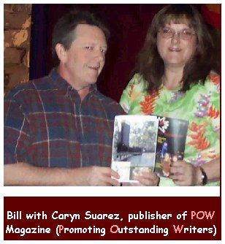
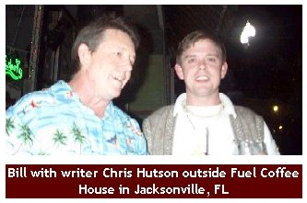
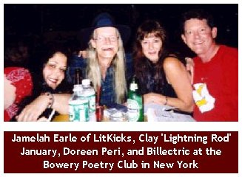
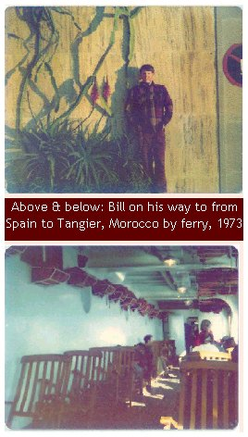
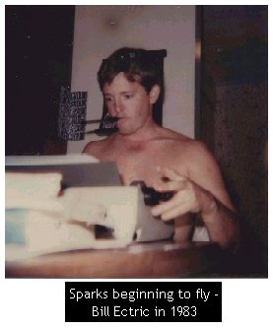
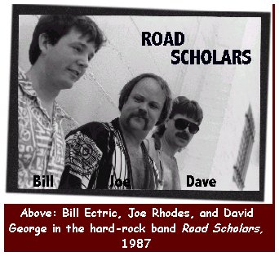

http://billectric.org/billectric.html

