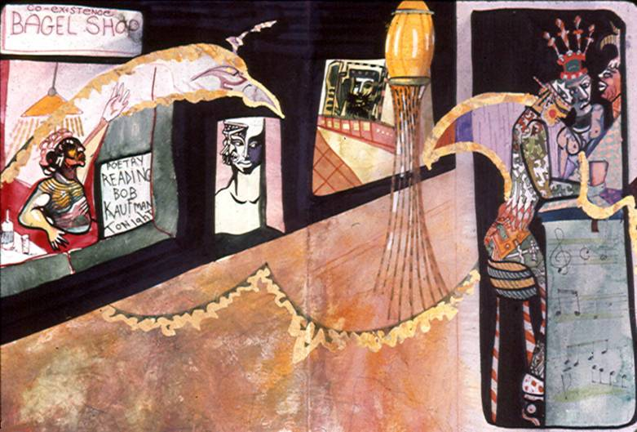
Bob Kaufman Poet, The Beat Saint of San Francisco

When Bob Kaufman was in his very early 20’s he and I were friends. We remained friends until he died, or another way to put it which I prefer is that his body simply could not hold any longer the powerful spiritual being this creative master had become. As human beings go, and as any photograph of him will tell you from the early beat days of the fifties, Kaufman’s young unique physical beauty was astounding. His beauty was astounding to anyone. And it created jealousy amongst the ugliest of souls. There were very few such souls in San Francisco then, some were poets and writers and the worst were San Francisco’s police. Two of these devils were street patrolmen named Bigarani and his cruel sidekick Cuneio. These two vile creatures walked the beat. What that meant then was this. They were police patrolmen who had a regular beat that they walked from China town to the bottom of Russian hill, throughout North Beach and Telegraph Hill. There is so much of the tales of Bob Kaufman it is hard to begin anywhere. But there is one that stands out in my mind at the moment.
During the part of the life of Kaufman that he spent on Telegraph Hill, he created a masterwork. A newspaper of sorts called “Beatitude”; a play on words of beat. It was a brilliant creation which printed his poems and others art freely without charge and without restriction. “Beatitude” is sought after today by museums throughout the world. Beat was a police term for the route that the patrolmen were assigned to walk everyday they worked. It is ironic that beat patrolmen and beat artists existed in a horrible opposition to each other brought about by a city hall that changed professional criminal politicians at each fraudulent election. The cop on the beat and the beat on the street, that’s one way of describing the world I lived in with “saints becoming” like Kaufman in 1955’s San Francisco.
In those days cops did not have police radios they carried around. That’s why they always walked in pairs It was a way insure them some protection. If they got into trouble with those they abused everyday, they had to get to little blue metal police call boxes. They had to open them with a key, pick up the phone inside which would activate the North Beach police station a few blocks away, which would then dispatch a police car to help them. The cruelty of these two, Bigarani and Cuneio was legendary in North Beach. We all knew they were enough of us artists, even with the cop’s guns, to put them out of action anytime we wanted to keep them from reaching that little blue police call box to summon help. But somehow we never did. They went on in North Beach five or six years and damaged many people physically. One of them was this same, now internationally famous poet, Bob Kaufman. These criminal cops would steal from people’s homes and harass blacks and whites when they found us together even just having a cup of coffee. We used to say to each other “One day these guys’ karma is going to catch up with them.” Little did we know how true that observation would become. Two short years after they were assigned a new beat to walk together on the other side of town in the very tough mission district, they were found handcuffed together to a telephone pole, half dead from a nasty beating. Cuneio was shot in the leg with his own gun. Bigarani was slumped to his knees with his badge stuck in his fat ass. I remember us all laughing about it when we read it in the Chronicle newspaper one morning. They had caused us so much hell that it really felt good to laugh at the newspapers account. After that, the next thing that appeared in the paper about these two was that they were both indicted by the district attorneys office. By this time, we are in the late sixties and city hall had changed from fascist right wingers to pot smoking left wing politicians. That’s the last anybody ever heard of Officers Bigarani and Cuneio. It was as if there were a devil who sent his minions to harass street angels. In some way, they failed their master and so met a fate which was the devil’s poetry itself. They simply evaporated in the memory of the public while those they persecuted, and especially Bob Kaufman, went on to a world fame for the things they had done. Kaufman, for example, already tired of the harassment and brutality that had been dished out to him while he wrote beautiful poetry with bruised fingers on sheets of old paper lying around somewhere that he found, went on to inspire other creative minds.
This Bowen painting from the Johnson collection is called “Bob Kaufman’s Funeral Parade”. It is easy to see in the painting the reality of that day with the friends of Bob crowded together on one side of the painting and the hired band that played at all the Chinese funerals marching out of the fog down Columbus Street from Broadway towards Market Street. The parade marched playing tubas, trumpets, and drums, with someone holding a box of Bob Kaufman’s ashes honoring the great poet. Once past Vesuvios and Specks Bar the parade dispersed into Bob’s bohemian haunts of North Beach. I remember Bob’s ashes were mixed in some drinks at Vesuvios and some were put into the ocean. He was a poet. His poetry is taught today in France, at the Universities in Paris.
There are several things to remember about Bob Kaufman and that go beyond Bob and that are inherent in this painting. The first thing to remember about this painting is that Bob Kaufman is dead. Thinking about this is the reason I made the painting. Equally important to being dead is to have been born. One cannot exist without the other, a fact avoided and forgotten by most human beings. Of course, witnessing and being part of that short and astonishing parade of honor for the impoverished creative genius, tootilling trumpets and booming tubas and drums celebrated at that moment in time the life and death of the poet. Marching past the shop, City Lights Books, where his brilliance was sold in books and pamphlets and poems and from which he had rarely received enough money to buy a pack of cigarettes that he would smoke silently, the parade continued on. There was another part of his life I cannot ever forget. He would walk the streets smoking silently. He stayed silent; never uttering a word since the day that president John F. Kennedy was assassinated. Bob knew something so profound about that terrible murder that murdered something in us all, that it could only be expressed by him by refusing to utter a word for 15 years. In most of the world people who take a vow of silence are looked upon as saints. Not in America, however, where this crime was just a peculiar fuel for armchair gossip.
Now Bob Kaufman was dead and the hunt was on for anything he had written and squirreled away somewhere or forgot somewhere else. Even poems he wrote on bathroom walls in North Beach were photographed and found their way into University texts in France.
So, why is Bob Kaufman important to history and Allen Ginsberg much less so? Ginsberg’s work appears more like Truman Capote’s famous description of Jack Kerouac; he is not a writer he is a typist. Ginsberg recorded the actions of his narrow perspective of an era. Bob Kaufman, however, especially in his poem “the endless rain”, touched the eternal.
Humanity, because of the development of its machinery of sight like the Hubble telescope floating in space, can now see the impermanence of the solidity of material reality. A truth told us for thousands of years by Tibetan monks. Now it must be understood. At the same time, humanity must now confront the paradox of the impermanence of “the endless rain.” Maybe Bob’s greatest poem and message to the world. Bob Kaufman was not just a poet who fell upon hard times; he was hard times itself whose honesty fell upon humanity.
Usually as an artist, I am interested in the reaction my paintings evoke in others. The new thoughts, the growth, sometimes the anger and sometimes the humor, all of those human reactions people go through when they see my work, intrigues me. However, this painting of Bob Kaufman’s funeral march is very different. It’s different because I believe it touches something eternal as did Bob Kaufman’s poem “the endless rain”. And by touching the eternality which he wrote, in turn I was inspired and understood that I was inspired by Kaufman’s work and life. Viewing “Bob Kaufman’s Funeral Parade”, I remember the lessons I learned from what this genius brought to humanity with his writing. For me, the relief of shallowness banished, which was his life, added a permanent creativity to me that I had not completely felt before. Because of Bob Kaufman’s life, death meant something. In most lives’ death means no more than birth and everyone of us is born and everyone of us dies. Bob Kaufman left the human race a legacy of hope to the yet unborn. In fact, a legacy that can make other humans great. All they need do is read what he said in his writing.
Often greatness is masked for its own protection in absurdity. Bob Kaufman’s life was such a mask. How absurd that the great poet, seen as a broken bum walking the streets of North Beach, would be unseen and unknown by the buyers carrying his brilliant words in their little City Lights Bookshop sacks as they passed each other. This is a high absurdity, even a form of horrible performance art beyond tragedy. How careful the people are that no spot or stain gets on the books or paper that his words are printed on. Yet he himself was stained from head to foot with unkemptness and dirt and former youthful beauty turned into scars and broken teeth by the blows of fools that passed through his life. Because he was alive, he couldn’t himself be carefully put upon a shelf, thus the absurd hides brilliance here. Yet, no where will you find in his writing a reference to the absurdity of life because to him, who saw the truth, life was a miracle with nothing absurd about it
Narrated by Michael Bowen to R.W. Bruch
Stockholm Sweden 2006
Copyright R.W. Bruch

